LICKING VALLEY LPDC
PROJECT ACTIVITIES FORM
(COVID)

Name:

School:

Project title and description:

Number of contact hours requested: (You are limited to 30 hours per project.)

How does this relate to your professional development plan? (Please reference specific goals from your plan.)

- Please complete the above form, print out a copy and submit it to your LPDC representative prior to beginning the activity.
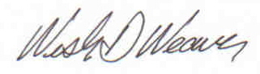

LPDC Pre-approval: ________________________________ Date: __9/22/20______

- When the project is finished, return the pre-approval form along with the finished project and an accounting of the dates and time spent on the project (please use project hours form) to your LPDC representative for final approval.

LPDC Approval:

Yes _____ No _____

CEUs granted _____

___________________________________ ____________________
LPDC Representative Date

